HOW TO CHECK IN CLIENTS
- Greet clients
- Show them where restrooms are if it’s their first time in
- Offer cold water (have bottled water set up on front desk for check-ins)
- Let client know their artist will come and get them as soon as their station is set up
- Make sure waiver is done (see steps below)
- Collect payment from client if needed (see Artist payment chart). *Amount due is listed on check-in form.
VCITA CLIENT/WAIVER LIST
- VCITA should be open in the browser with client list open.
- If the client list is not open, click “Calendar” > “Appointment List” > and set Appointment date to today’s date
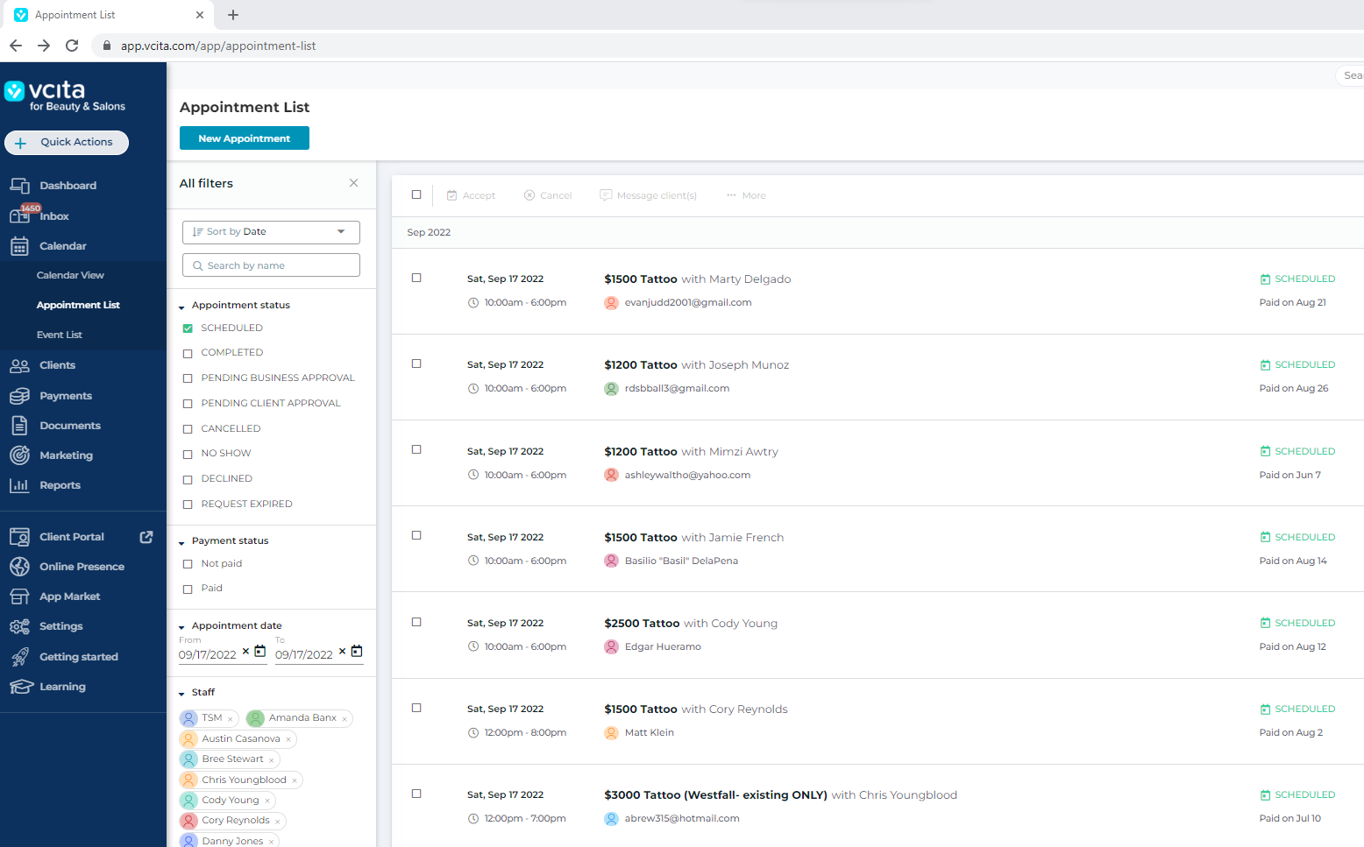

REVISED 09/15/22

CHECKING CLIENT WAIVER FOR COMPLETION
- Booking manager will leave client list on front desk. If the “w” next to client’s name is highlighted (w), then their waiver is done. If the “w” is not highlighted, then client needs to complete their waiver.
- If client needs to complete waiver, they can either use the link that was sent to them via text/email the day before or the QR code at the Front Desk.
- To see if client’s waiver is complete, click on their name on client list:
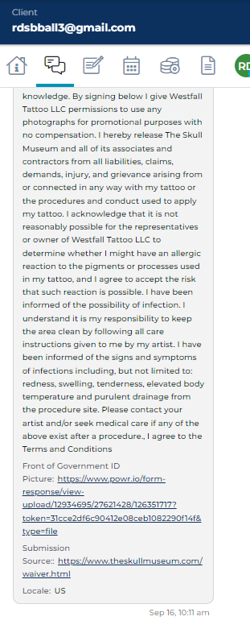
- Then, click the “conversation” tab
in the client’s profile or a grey waiver
with today’s date. *See screen shot
NOTE: Waivers must always be completed within
24hrs of the client’s appointment date and
BEFORE they start their session with their Artist)

